**Using Putty**, logon to the server.

Type **mysql**, to use the MySQL server.

Type **show databases;**

This will show you all of the databases you have permission to use.

Use “your” ap database (ap_userid).

Type **use ap_ userid;**

* Screen clip or **screenshot your SQL statement and result of the SQL statement for all questions**.
* Place this under the question it is associated to.
* Please be sure to scale your screenshot so I am able to easily read the SQL statement and results. I will not be able to grade submissions where the screenshots need to be scaled in order for me to read the information.
* Each question should use only one SQL statement.

1. **Create a table** named **terms_backup** that is a copy of the terms table. (7 pts)

2a. **Create a table** named **terms_backup_partial** that is a copy of the terms table and contains only the rows where the terms due days are 10 – 30. (5 pts)

Hint: Use the WHERE clause with a BETWEEN operator; CH3 pg. 98 - 99.

2b. **Select all** columns and rows from **terms_backup_partial** to ensure correctness. (2 pts)

3. **Delete** the **terms_backup_partial** table. (7 pts)

4a. Write an **INSERT statement** that adds this row to the **terms** table: (6 pts)

terms_id 6

terms_description Net due 120 days

terms_due_days 120



4b. **Select all** rows and records from the **terms** table to see your record. (2 pts)

5a. Write an **UPDATE statement** that modifies the row you just added to the **terms** table. (6 pts)

Hint: This statement should change the terms_description column to “Net due 125 days”, and it should change the terms_due_days column to 125.

5b. **Select all** rows and records from the **terms** table to see your updated record. (2 pts)

6a. Write a **DELETE statement** that deletes the row you added to the **terms** table in Q4a. (6 pts)



6b. **Select all** rows and records from the **terms** table to see your record is no longer there. (2 pts)

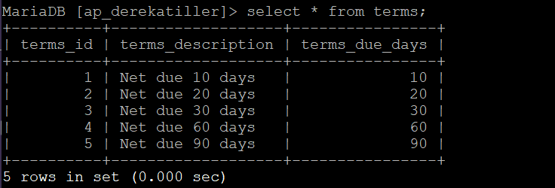

7. Write an **INSERT statement** that adds this row to the **Invoices** table and **not** use a column list or a SET: (7 pts)

Hint: Refer to CH5 pg. 153, for information on how to get MySQL to *generate a value for the invoice_id field.*

*(Important: Notice the invoice_id generated by this SQL statement. You will use it in Q8a.)*

invoice_id *the next automatically generated ID*

vendor_id 32

invoice_number AX-014-027

invoice_date 8/1/2011

invoice_total $434.58

payment_total $0.00

credit_total $0.00

terms_id 2

invoice_due_date 8/31/2011

payment_date null



7b. **Check your work** by selecting all columns, ordering them in reverse by the invoice_id and limiting the output to 5. (2 pts)

Hint: You may refer to CH3 pg. 109.

8a. Write an **INSERT statement** that adds these 2 rows to the **invoice_line_items** table: (7 pts)

Hint: Use the invoice_id generated in Q7 above.

invoice_id From Q7 From Q7

invoice_sequence 1 2

account_number 160 527

line-item_amount $180.34 $254.35

line_item_description Hard Drive Exchange Server update

9a. Write an **UPDATE statement** that modifies the invoice you added in Q7. (7 pts)

Hint: This statement should change the credit_total column so it’s 10% of the invoice_total column, and it should change the payment_total column so the sum of the payment_total and credit_total columns are equal to the invoice_total column. It is ok to get a warning on this statement as the math causes the decimal places to go long and it will truncate to the definition.

9b. **Check your work**: SELECT * from invoices WHERE invoice_id = 115; (2 pts)

Hint: Notice that you should now have a payment_total and a credit_total … look at 7b, these columns were zeroes before.

10a. **Look at vendor with an ID of 44** because you will update this vendor record in 10b.

--SELECT * FROM vendors WHERE vendor_id = 44;

10b. Write an **UPDATE statement** that modifies the **vendors** table.

-- Change the default_account_number column to 403 for the vendor with an ID of 44. (7 pts)

10c. **Check your work** by re-executing statement from 10a. (2 pts)

11. Write a **DELETE statement** that deletes the row that you added to the **invoices** table in Q7.

Hint: When you execute this statement, it will produce an error since the invoice has related rows in the invoice_line_items table. **Show this error.** (5 pts)

To fix this error, precede the DELETE statement with another DELETE statement that deletes the line items for this invoice. There should be a total of 3 rows deleted, two from invoice_line_items and one from invoices. (5 pts)

